

**AP Calculus BC**

Q1 Interim Assessment

Test Booklet 2

Multiple Choice - Calculator

October 2017

School: _____________________________________________

Student Name: _____________________________________________

Teacher: _____________________________________________

Period: _____________________________________________

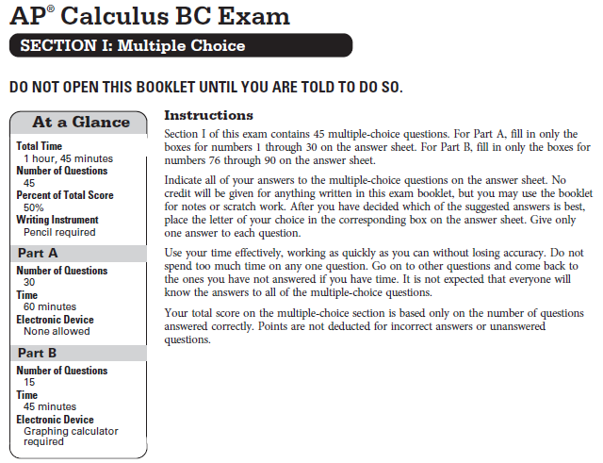

**CALCULUS BC**

**SECTION I, PART B**

**Time – 45 minutes**

**Number of questions – 15**

**A GRAPHING CALCULATOR IS REQUIRED FOR SOME QUESTIONS ON THIS PART OF THE EXAM.**

Directions: Solve each of the following problems, using the available space for scratch work. After examining the form of the choices, decided which is the best of the choices fiven and place the letter of your choice in the corresponding box on the answer sheet. No credit will be given for anything written in this exam booklet. Do not spend too much time on any one problem.

**In this exam:**

1. The exact numerical value of the correct answer does not always appears among the choices given. When this happens, select from among the choices the number that best approximates the exact numerical value.
2. Unless otherwise specified, the domain of a function is assumed to be the set of all real numbers for which is a real number.
3. The inverse of a trigonometric function may be indicated by using the inverse function or with the prefix “arc” (e.g. ).

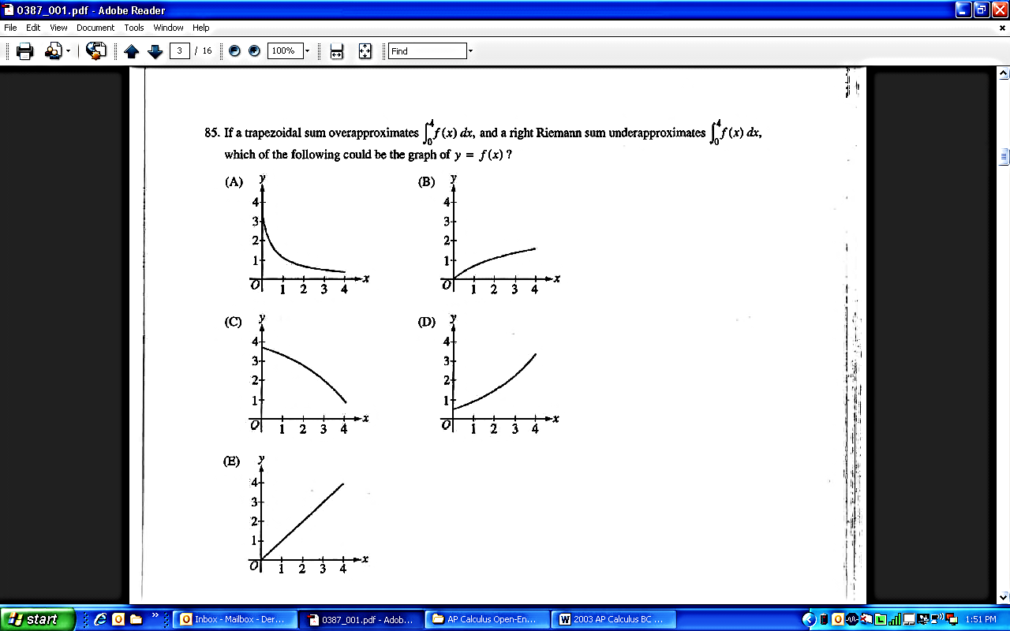

1. The graph of the function is shown above for . Of the following, which has the greatest value?
3. Left Riemann sum approximation of with 4 subintervals of equal length.
4. Right Riemann sum approximation of with 4 subintervals of equal length.
5. Not enough information to determine which has the greatest value.
6. The derivative of the function is given by . On the interval , at which of the following values of does have a relative maximum?
7. -1.970 and 0
8. -0.475, 0.542, and 1.396
9. -0.475 and 1.396
10. 0.542 only
11. Let be a function that is continuous on the closed interval with and . Which of the following is guaranteed by the Intermediate Value Theorem?
12. has at least one solution in the open interval .
13. .
14. has at least one solution in the open interval .
15. for all in the open interval .

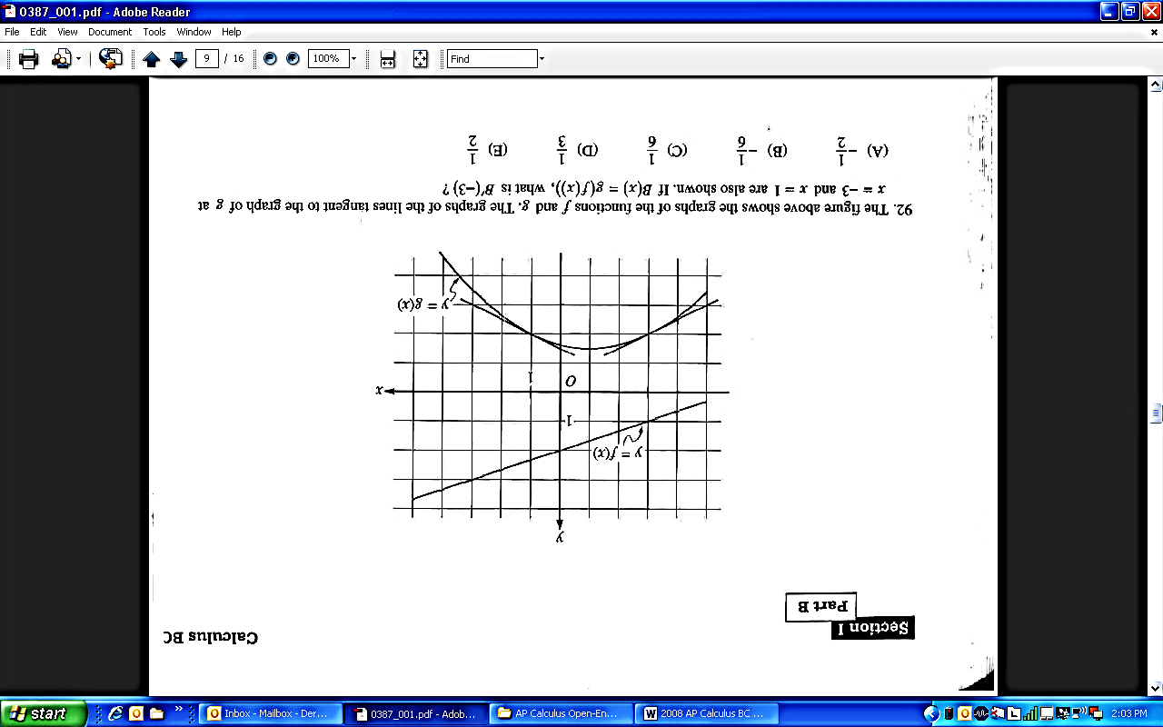

1. The figure above shows the graphs of the functions and . The graphs of the lines tangent to the graphs of at and are also shown. If what is ?
2. (B) (C) (D)



7. The volume of a cylindrical tin can with a top and a bottom is to be cubic inches. If a minimum amount of tin is to be used to construct the can, what must be the radius, in inches, of the can? (Note: The volume of a cylinder is given by )



12. Let be the function defined above, where and are constants. If is differentiable at , what is the value of ?
13. (B) (C) (D)
15. (B) (C) (D)

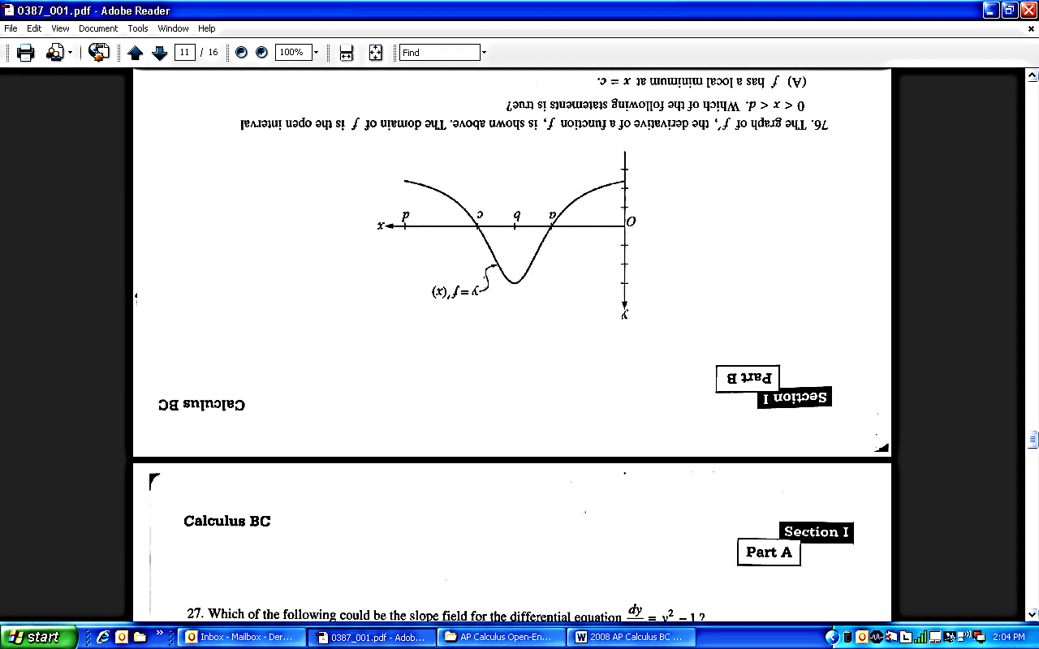

1. The graph of , the derivative of a function , is shown above. The domain of is the open interval . Which of the following statements is true?
2. has a local maximum at .
3. The graph of has a point of inflection at .
4. The graph of has a point of inflection at
5. The graph of is concave up on the open interval .

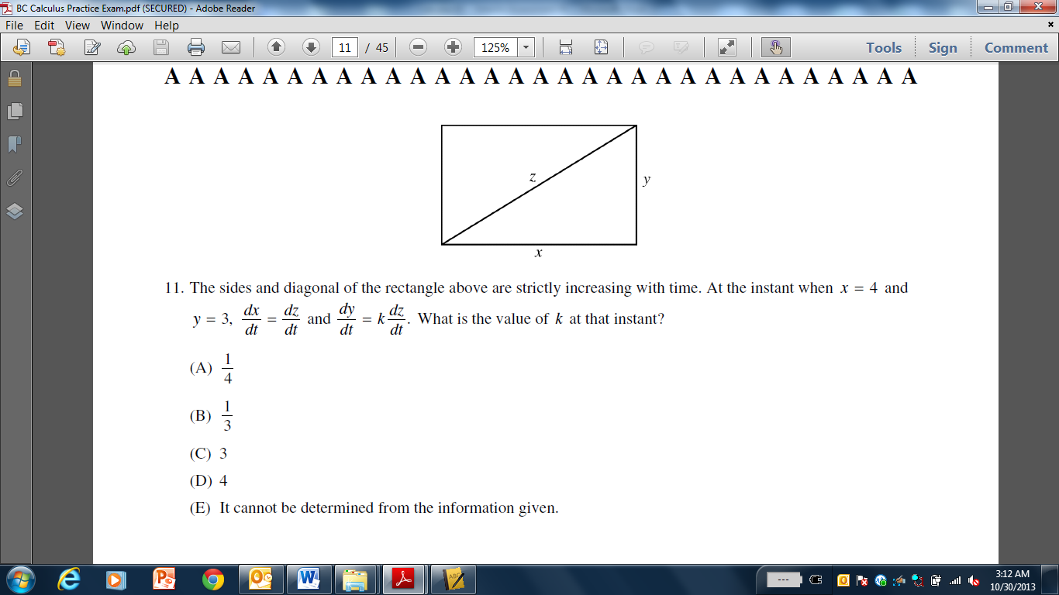

1. The sides and diagonal of the rectangle above are strictly increasing with time. At the instant when and , and . What is the value of at that instant?

(A) (B) (C) (D)

1. The function represents the rate at which gravel is poured into the back of a dump truck in pounds/second. Which of the following statements is the best interpretation of ?
2. At , there is a total of 1800 pounds of gravel in the back of the dump truck.
3. At , the rate at which the gravel is pouring is increasing by 1800 pounds per minute per minute.
4. At the gravel is pouring at a rate of 1800 pounds per minute
5. From to , 1800 pounds of gravel was poured into the back of the dump truck.
6. Consider the functions and given by and . At what

value of do the graphs of and have perpendicular tangent lines?

(A)

(B)

(C)

(D)

1. Let be a twice differentiable function such that and . Which of the following must be true for the function on the interval ?
2. The average rate of change of is .
3. The average value of is .
4. The average value of is .
5. I only
6. I and II only
7. I and III only
8. I, II, and III
9. Which of the following limits is equal to ?

**END OF SECTION I**

**IF YOU FINISH BEFORE TIME IS CALLED,**

**YOU MAY CHECK YOUR WORK ON PART B ONLY.**

**DO NOT GO ON TO SECTION II UNTIL YOU ARE TOLD TO DO SO.**